THE UGANDA INTERGOVERNMENTAL FISCAL TRANSFERS (UGIFT)

REPORT ON THE FINDINGS OF HEALTH CENTERS AND SCHOOLS IN NEBBI DISTRICT – WEST NILE REGION

Date: 4th September, 2026

NEBBI DISTRICT – WEST NILE REGION CAO:
- Mr. Muluuta Mugagga, warmly welcomed the team and introduced us to the DEO, DHO and Accounting officer.
- The DEO and DHO had an urgent meeting to attend hence they delegated their assistants to support
- They helped the team to inform the Health facility in-charges and head teachers of the Seed schools.
- The district did not have the specific UGIFT Asset register for the UGIFT asset that were provided to the specific facilities in our Scope.

PAMAKA HEALTH CENTER III, NDHEW SUBCOUNTY – NEBBI DISTRICT

Narratives from the in charge of the health facility. To a larger extent the facility and community have benefited from the UGIFT Program and this can be evidenced through the increase in number of patients and the facility has gained trust amongst the community due to reliable service delivery since its well-equipped.

FINDINGS

- 1 maternity ward building
- 1 Toilet
- All the required medical assets as listed in the attached facility register below and some of the photos.
- 1 Residential house for medical staff

CHALLENGES

- There is a challenge of power thus some machines are not in use e.g., the oxygen machine.
- The solar panel only worked for 3 months after the facility was commissioned but since then it has not been working.
- Few medical personnel due the increasing number of patients

RECOMMENDATIONS
  - We recommend to work and power and ensure reliable supply for the facility to enable usage of electric devices in service delivery
  - Employ more medical personnel’s

Field photos
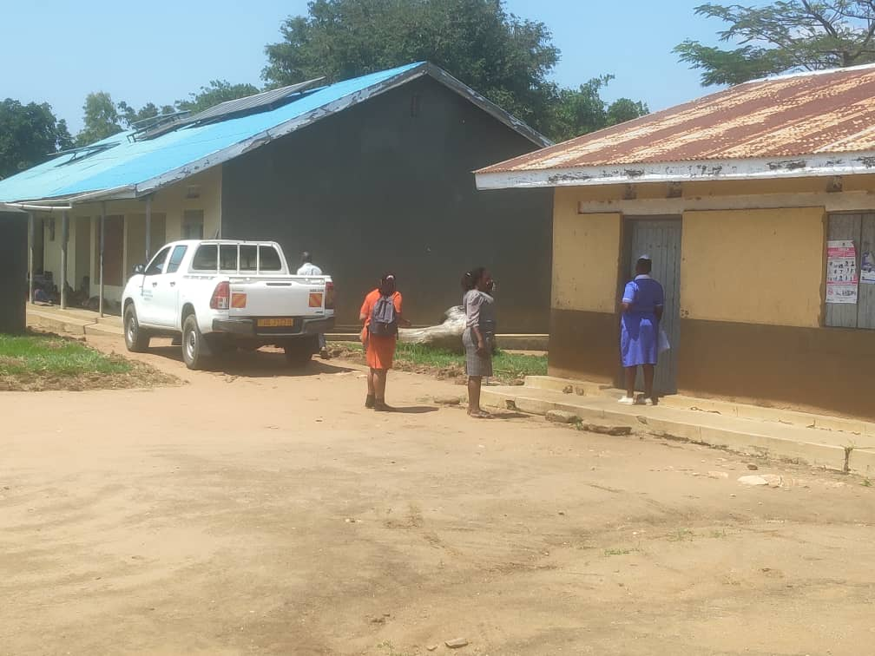
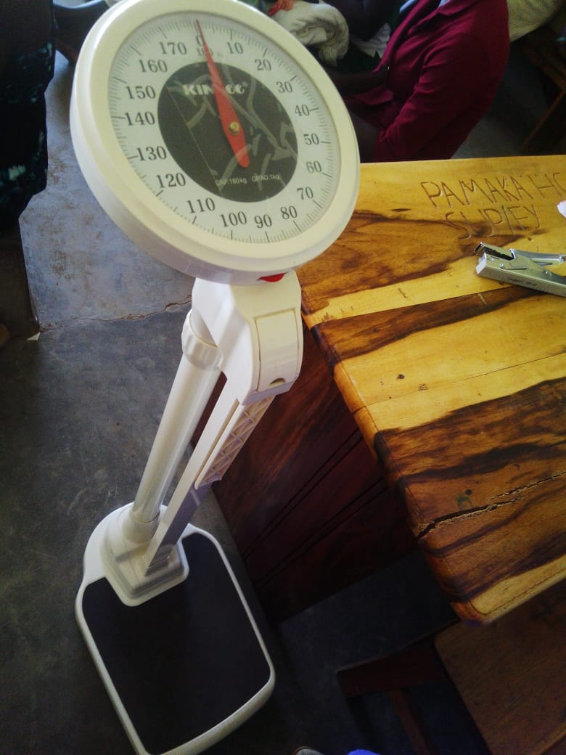
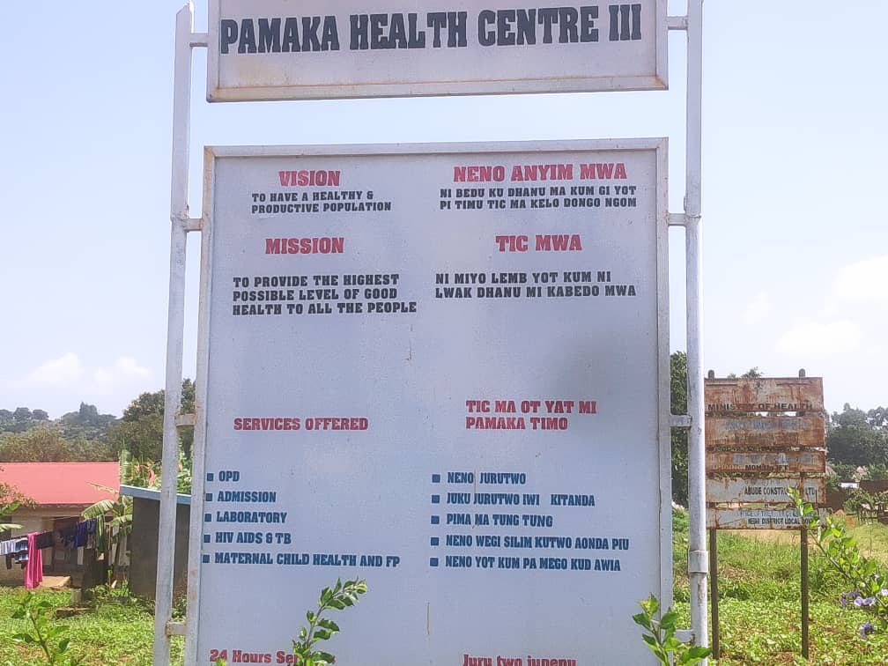
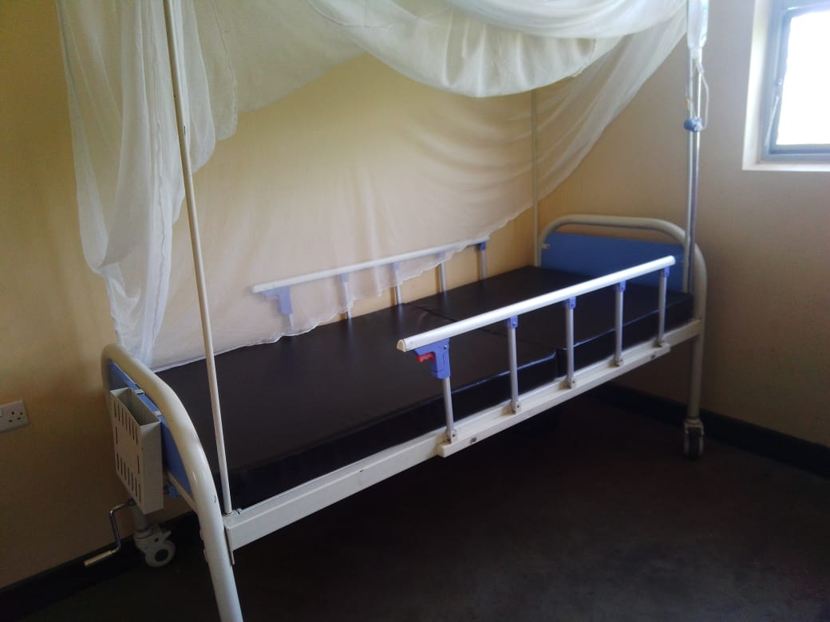

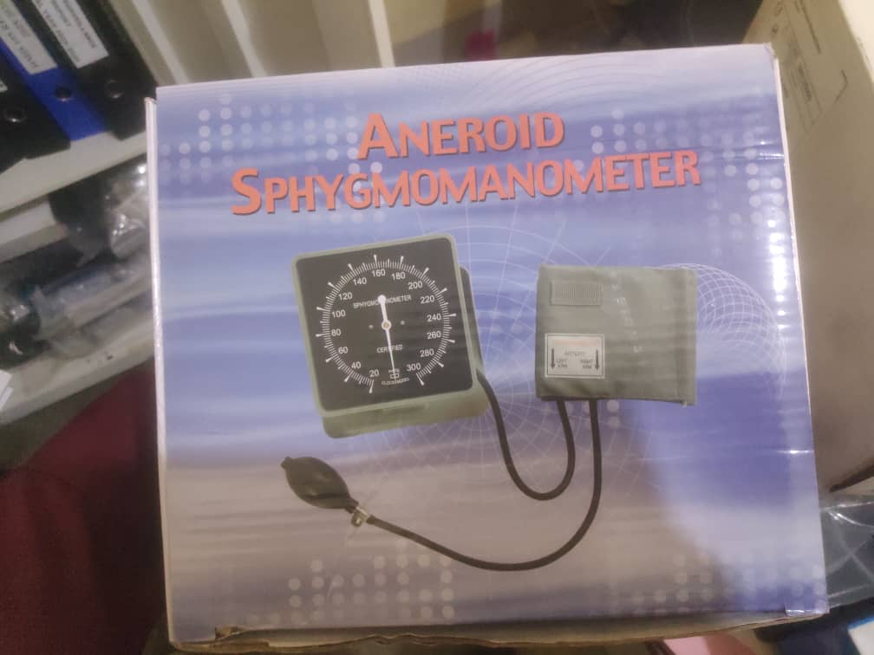
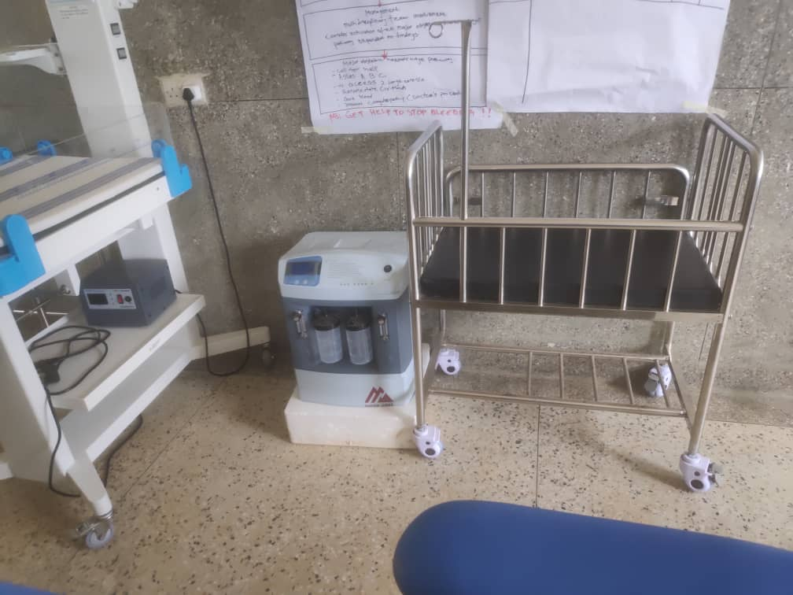
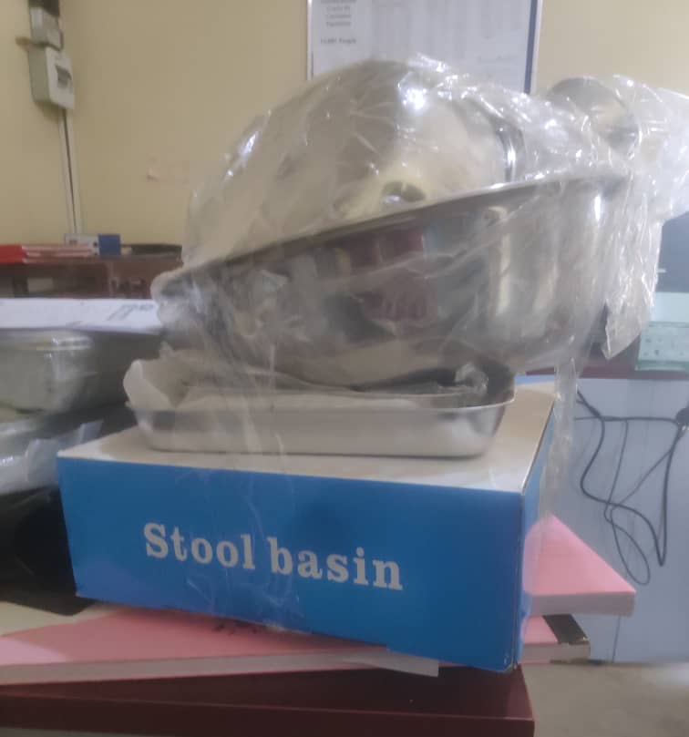
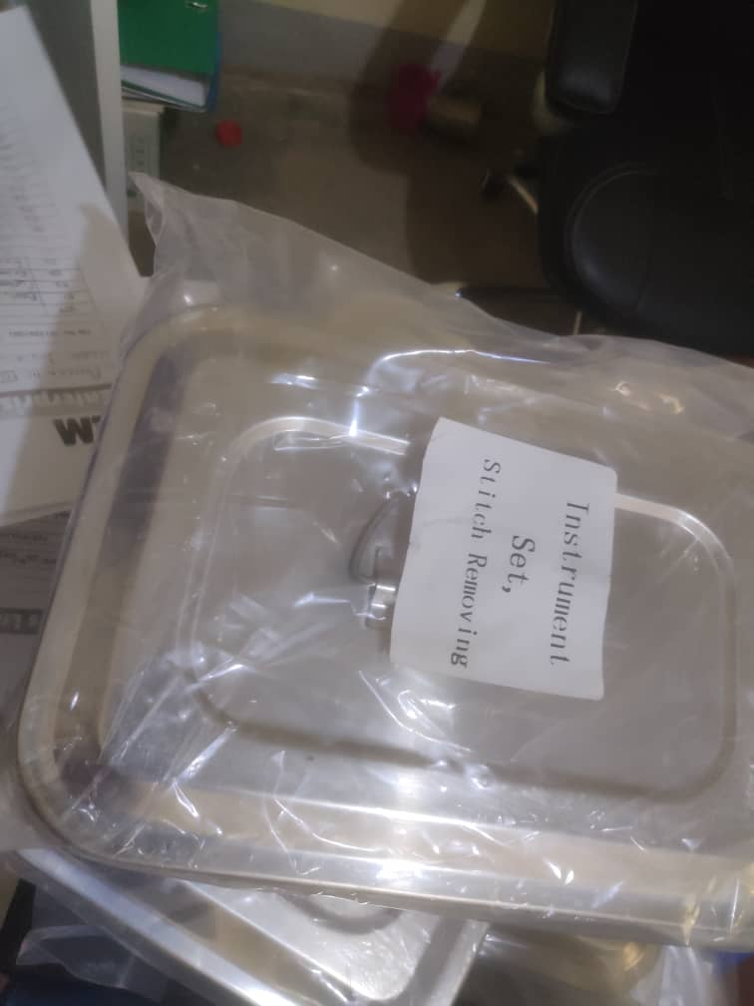
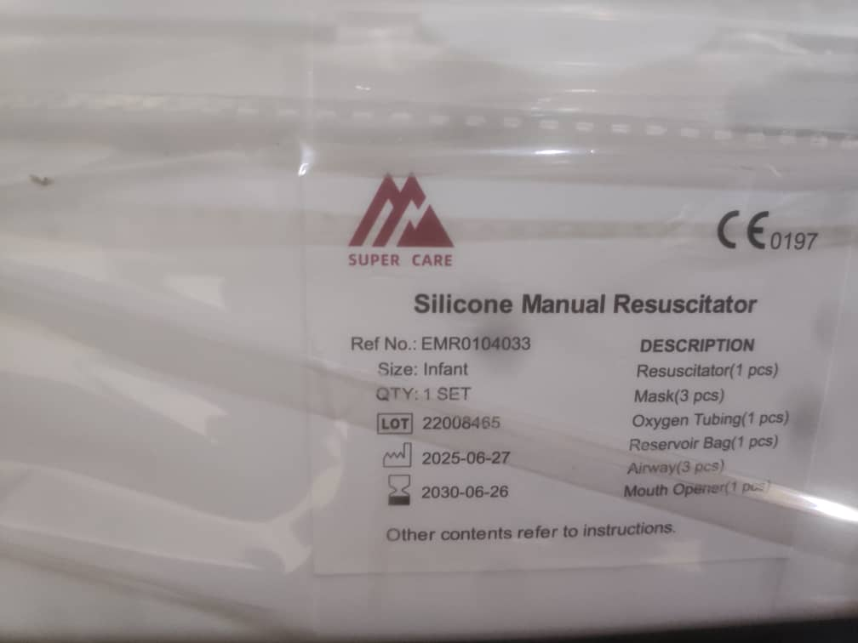
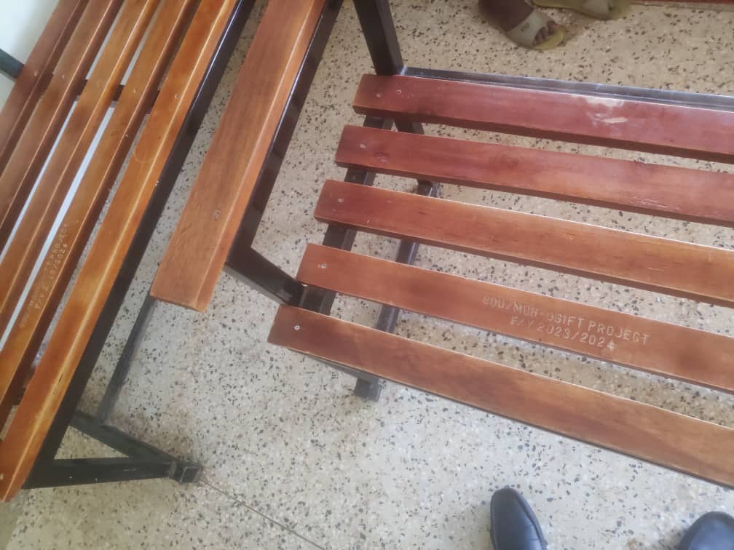
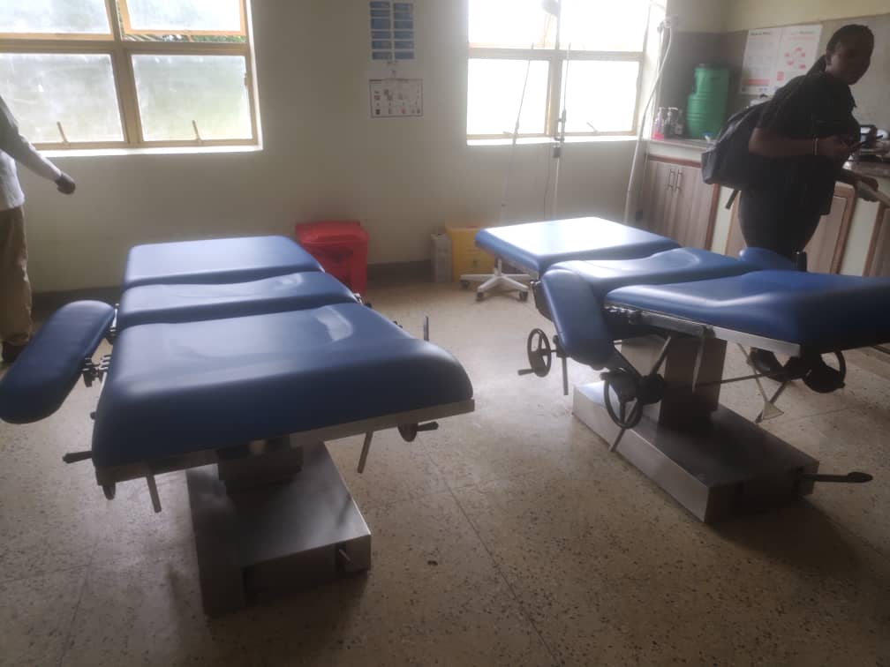

NDHEW SEED SCHOOL, NDHEW SUB COUNTY IN NEBBI DISTRICT
Information from the focal person in charge of the facility. We were warmly welcomed and given a guided tour around the school premises as we did the asset verification, the school so far benefited from UGIFT Program.
Note: The school is still under construction and structures are not complete thus no asset register for UGIFT assets. The ICT and Science lab equipments a still kept at the district headquarters. No school furniture was installed due to pending construction.

FINDINGS
- 3 Blocks each with 2 class rooms
- 1 Science laboratory block with two labs i.e. Biology and Chemistry
- 1 ICT block with two labs i.e. Computer room and Library room
- 6 Staff house units with 6 staff Kitchen units
- 2 Toilets at staff quarters each with 2 stanzas still on pit excavation level
- 1 staff school toilet with 2 stanzas still on slab level no structure
- 2 student toilets for both girls and boys each with 5 stanzas still on slab level no structure
- Not fenced

FURNITURE
- None installed yet

ICT DEPARTMENT
- Non installed still at the district in store boxed

CHALLENGES
- The delay in construction due to unreliable release of finances to the construction team hence the delay in construction has led to the delay in installation of other assets such as computers and science lab equipment

RECOMMENDATIONS
- Funds should be released timely to enable easy construction.

FIELD PHOTOS
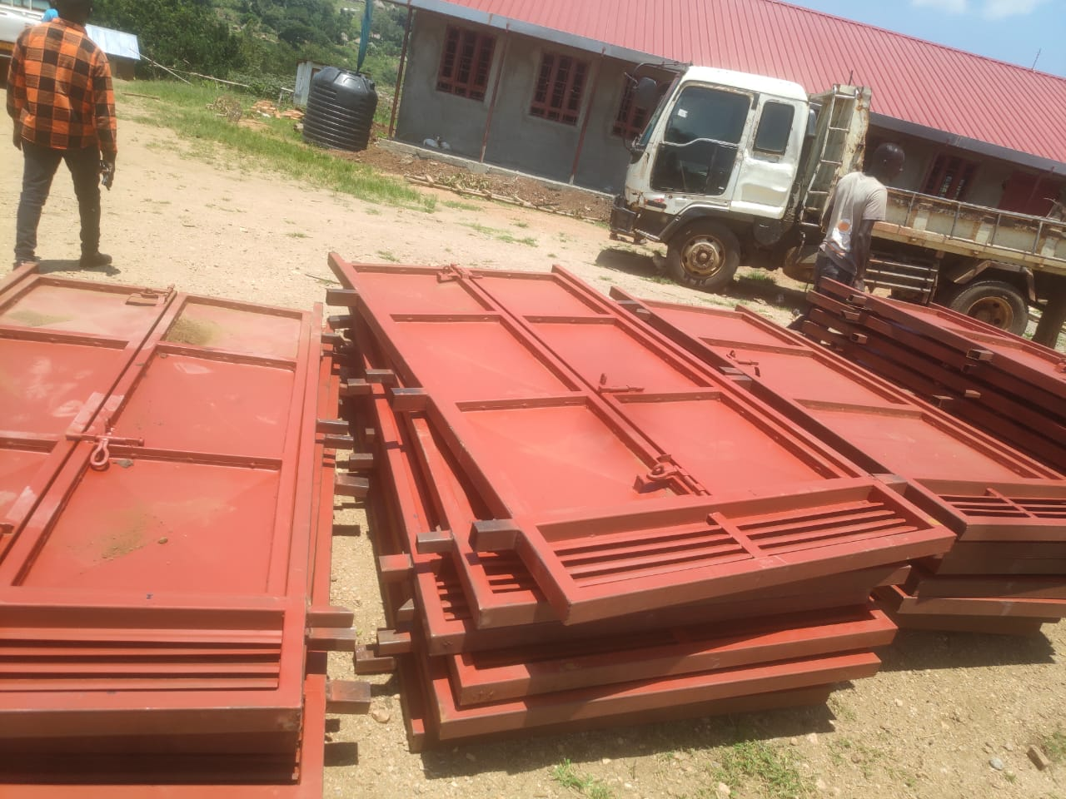
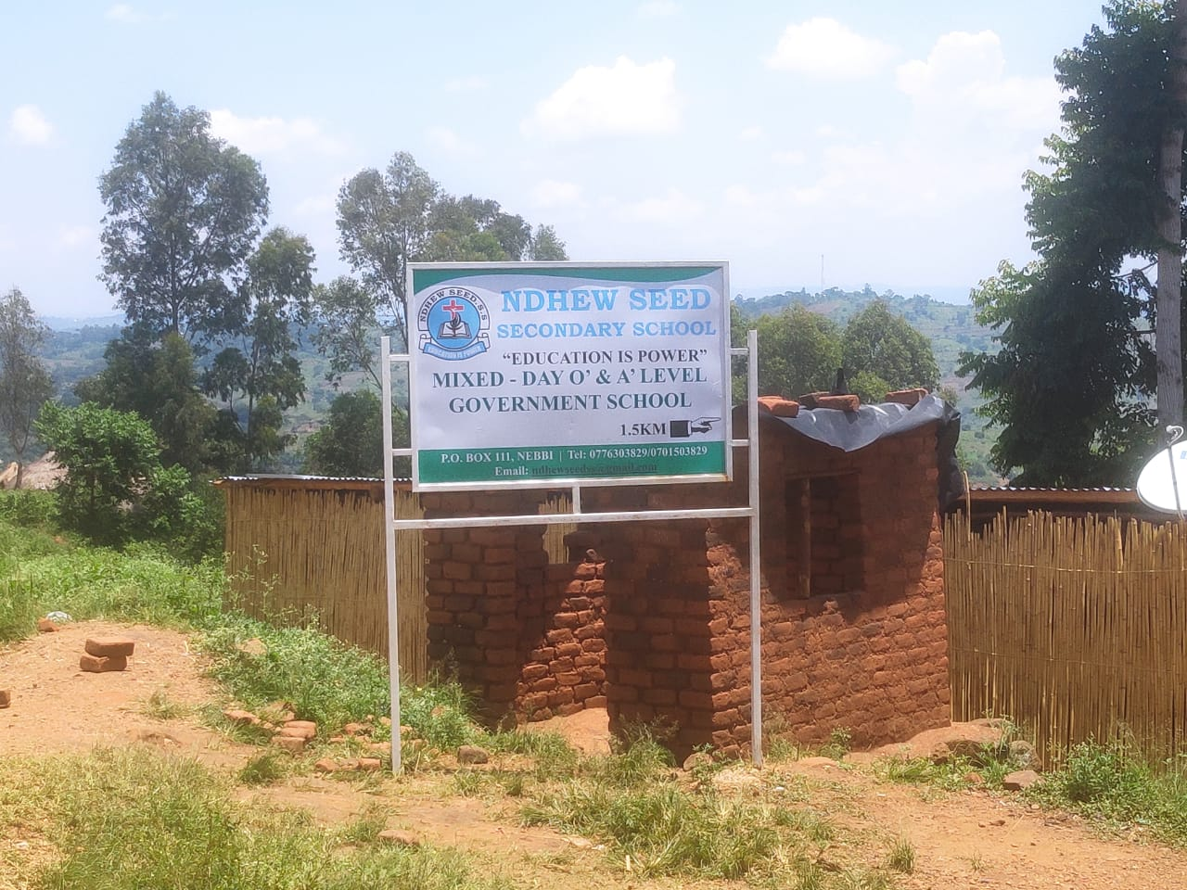

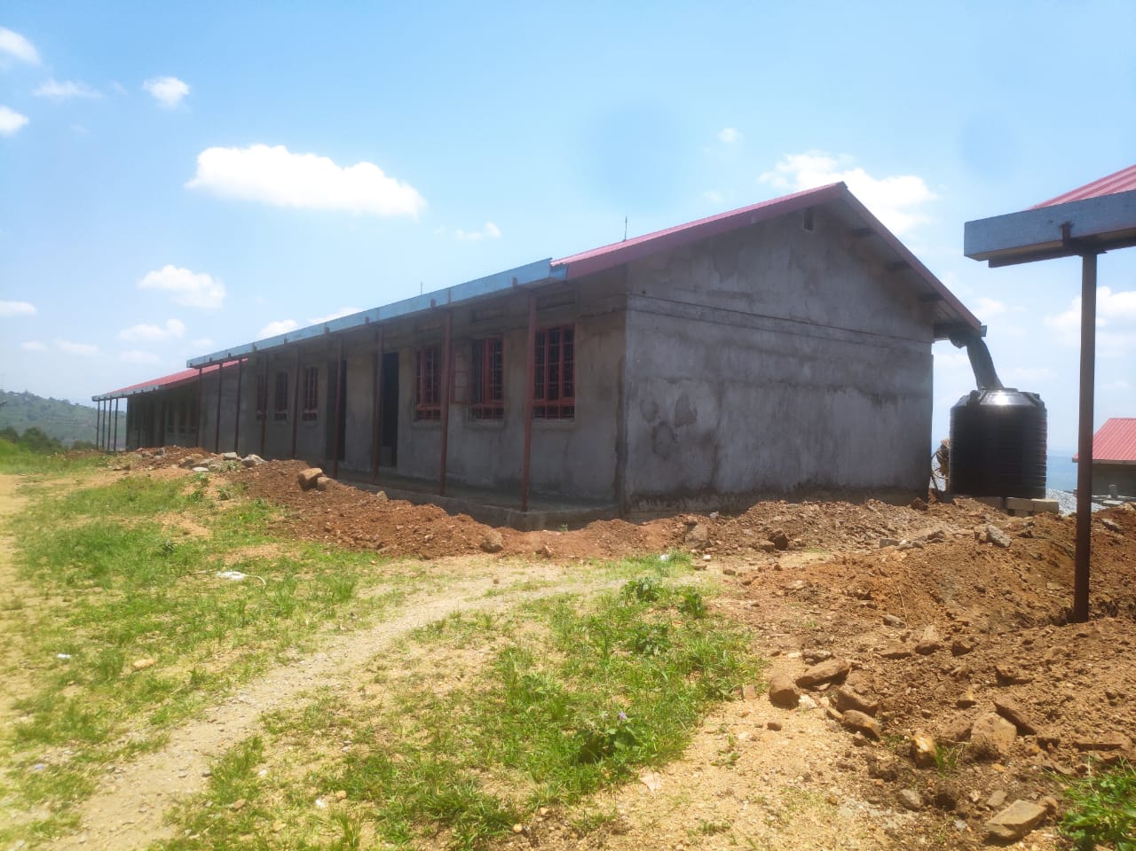
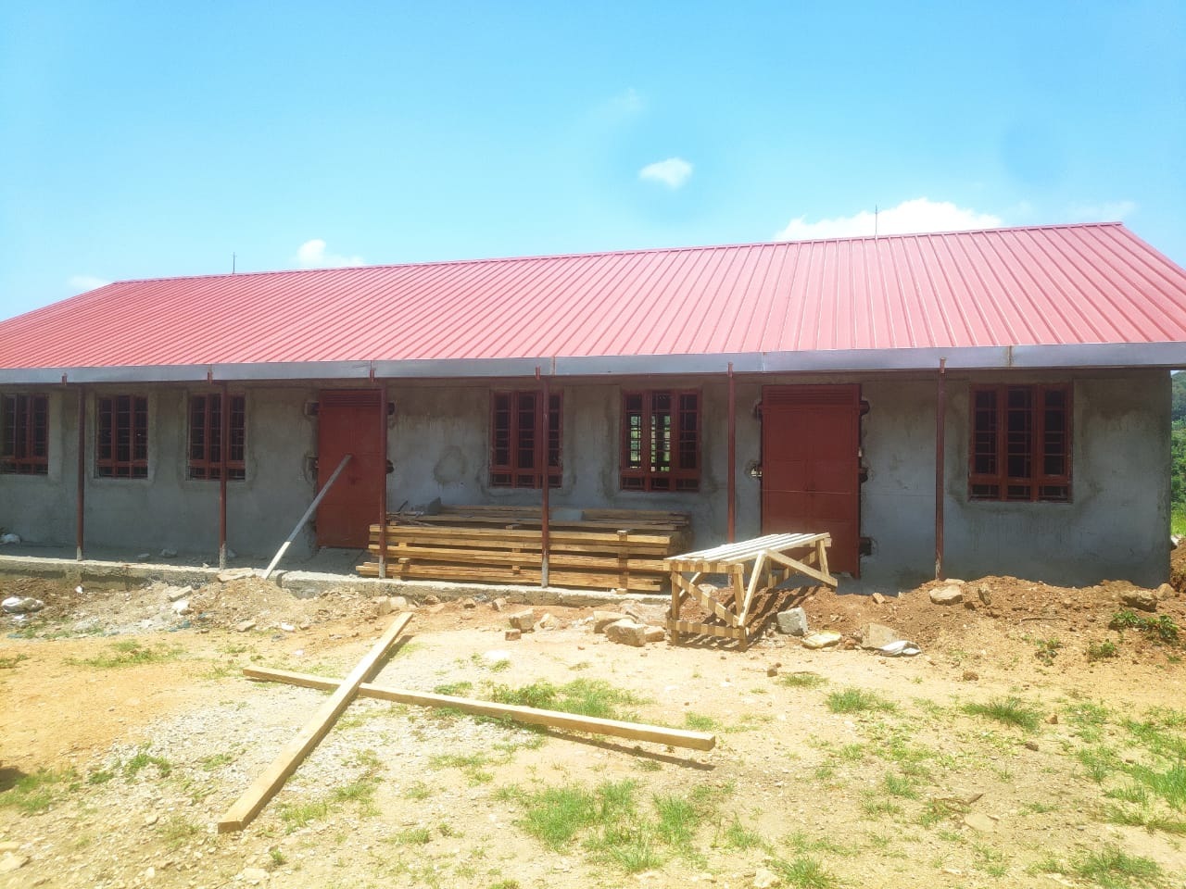

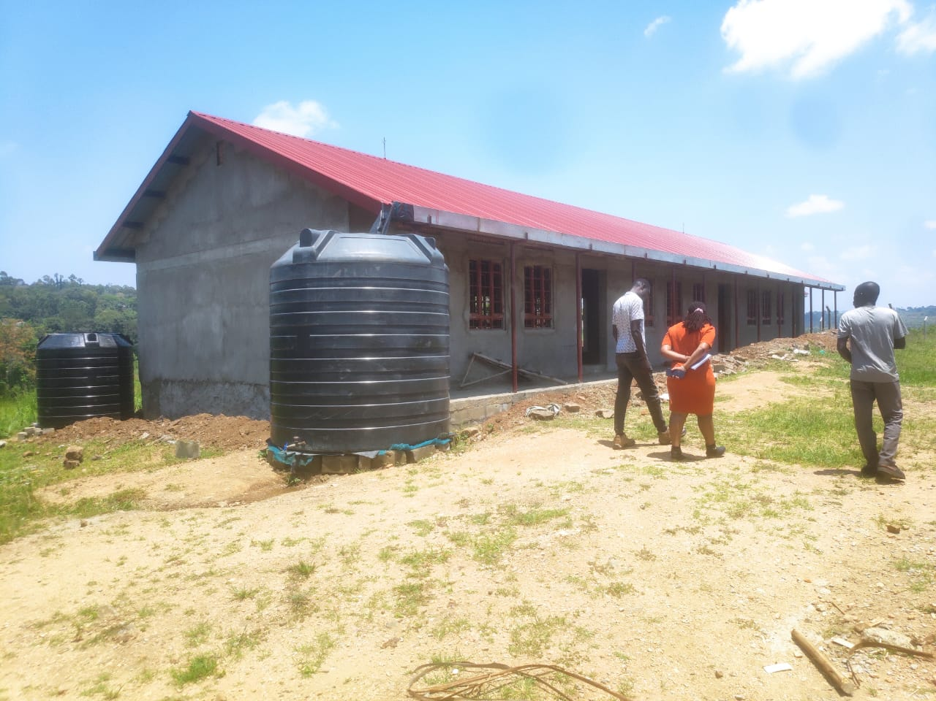
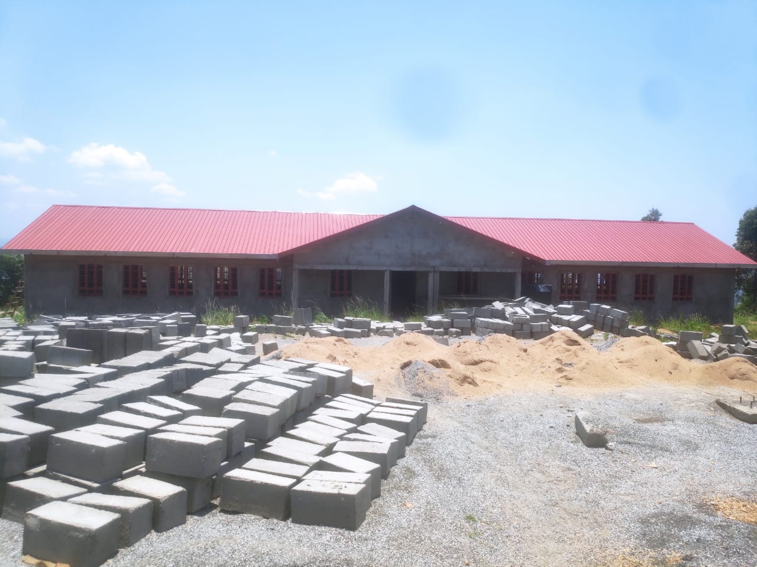

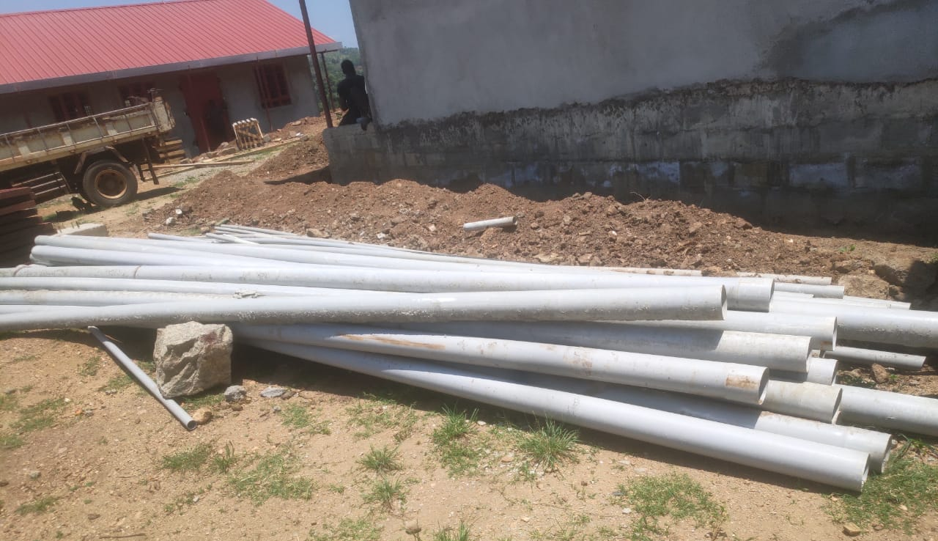
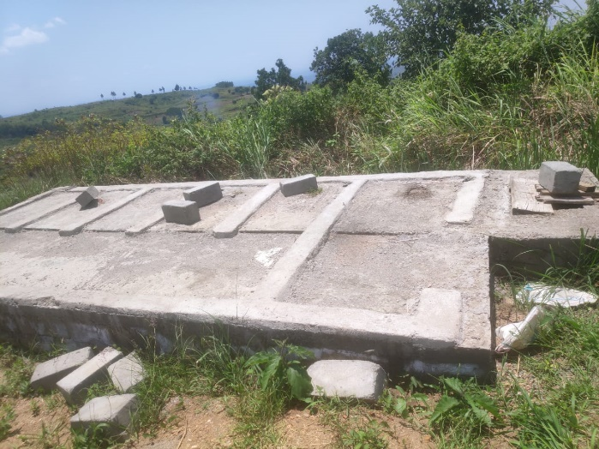

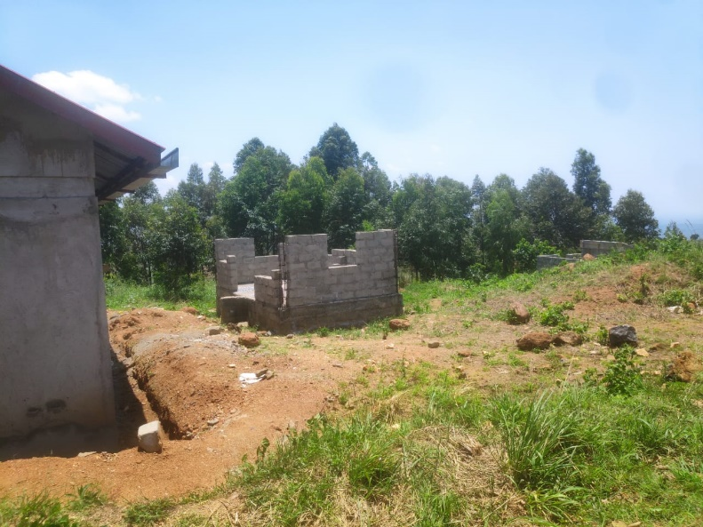
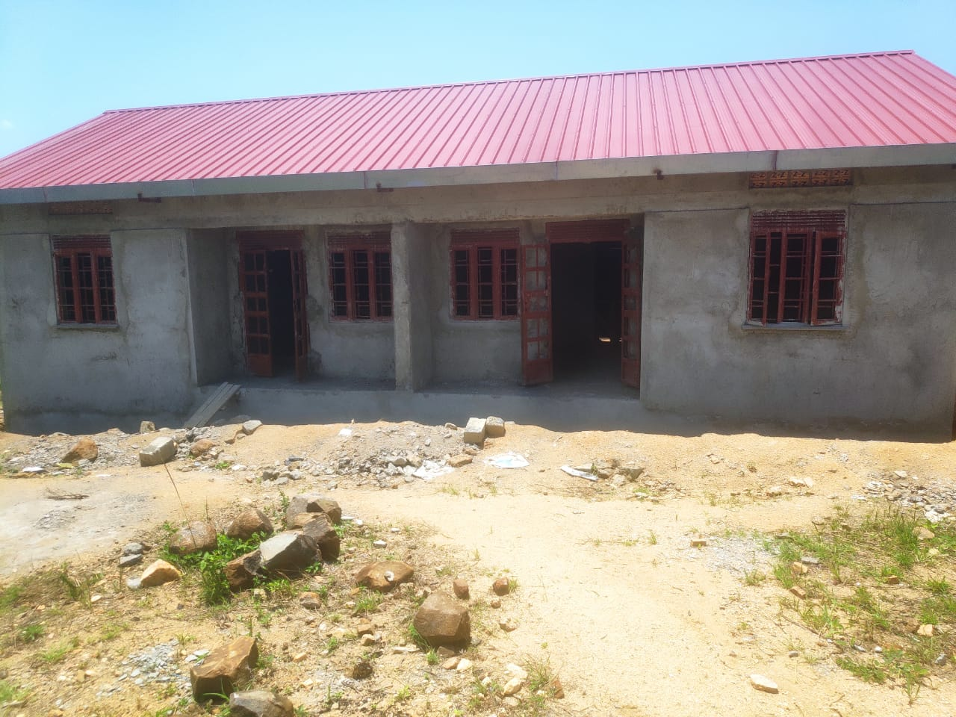

MAMBA SEED SCHOOL, KUCWINY SUB-COUNTY IN NEBBI DISTRICT
Information from the focal person in charge of the facility. We were warmly welcomed by the headteacher and given a guided tour around the school premises as we did the asset verification, the school so far benefited from UGIFT Program. A list of delivered ICT assets was shared.
Note: The facility is still under construction and has not been fully commissioned however, they use old structures to store the supplied UGIFT assets specifically ICT assets. These assets are connected but not fully functional due to the pending construction.
The Science lab equipments a still kept at the district headquarters. No school furniture was installed due to pending construction.

FINDINGS
- 3 Blocks each with 2 class rooms
- 1 Science laboratory block with two labs i.e. Biology and Chemistry
- 1 ICT block with two labs i.e. Computer room and Library room
- 6 Staff house units with 6 staff Kitchen units
- 2 Toilets at staff quarters each with 2 stanzas still on pit excavation level
- 1 staff school toilet with 2 stanzas still on slab level no structure
- 2 student toilets for both girls and boys each with 5 stanzas still on slab level no structure
- Not fenced

FURNITURE
- None installed yet

ICT DEPARTMENT
- ICT assets were delivered at the facility however these gadgets are connected but are not well installed and the school improvised a temporary storage of one of its old structures as they wait for construction completion of the ICT Lab and Library structure.

CHALLENGES
- The delay in construction due to unreliable release of finances to the construction team hence the delay in construction has led to the delay in installation of other assets such as computers and science lab equipment.

- there is delay in construction due to having the same contractor working on both Mamba and Ndhew concurrently hence the delay in construction has led to the delay in installation of other assets such as computers and science lab equipment. Additionally, there is unreliable release of finances to the construction team.

RECOMMENDATIONS
- Funds should be released timely to enable easy construction.

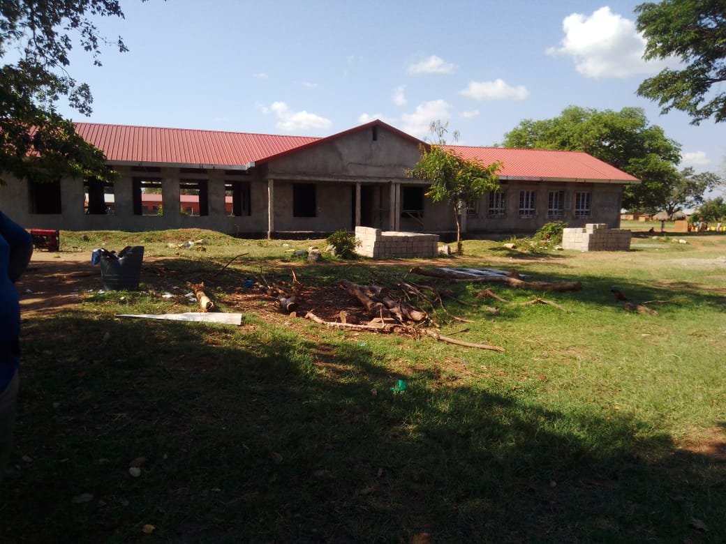
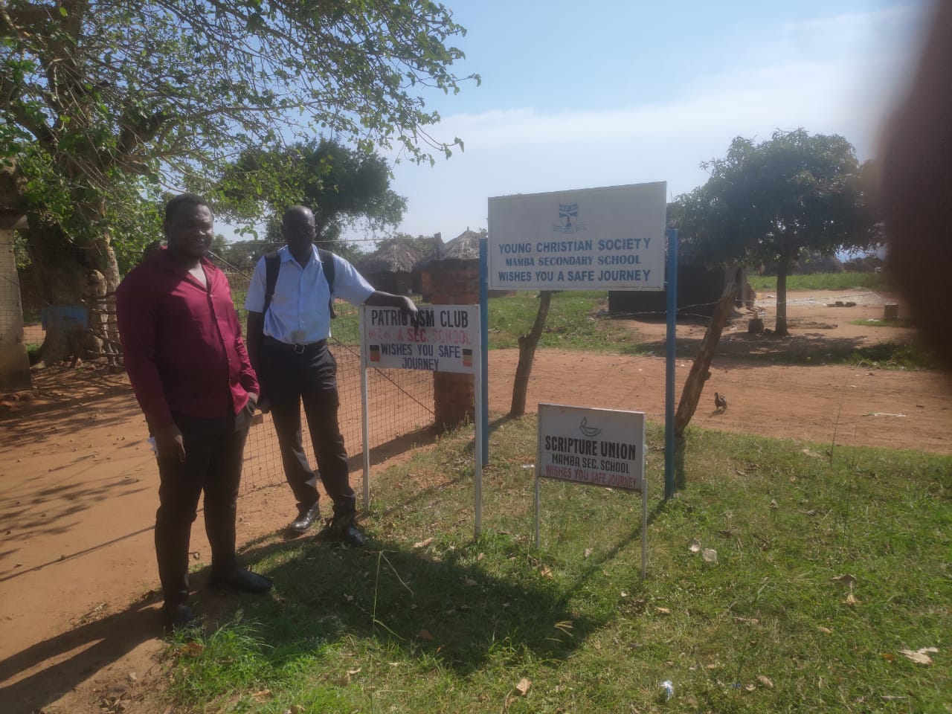
Field photos

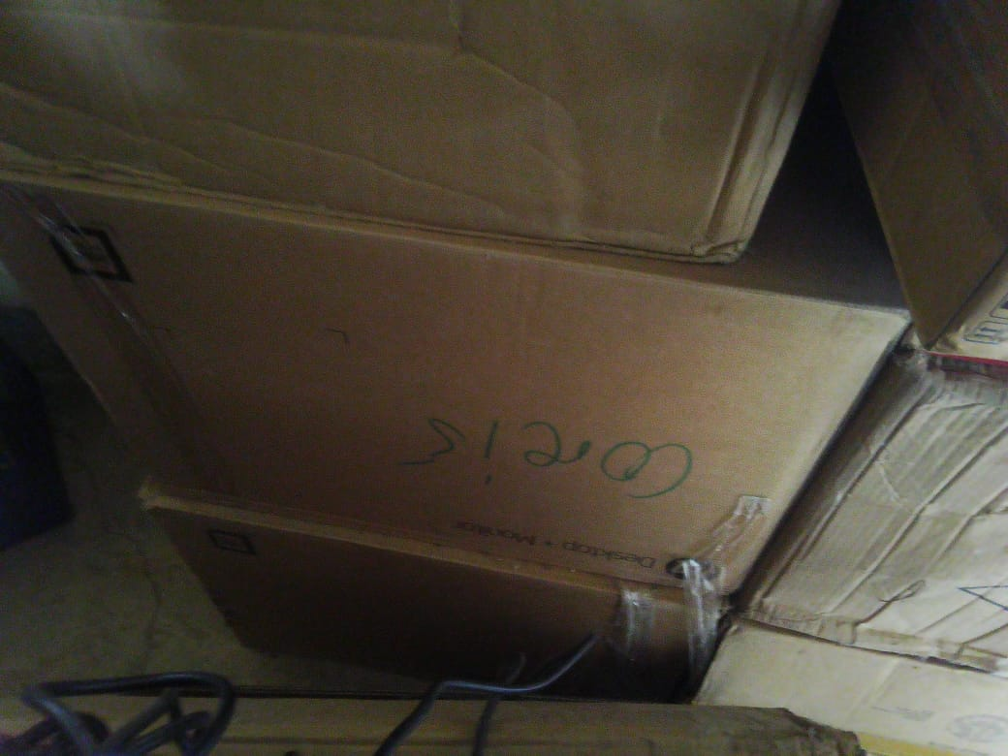
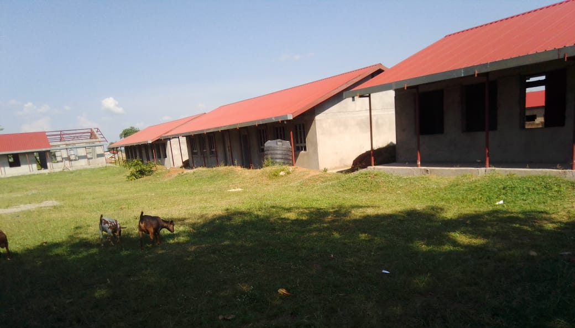
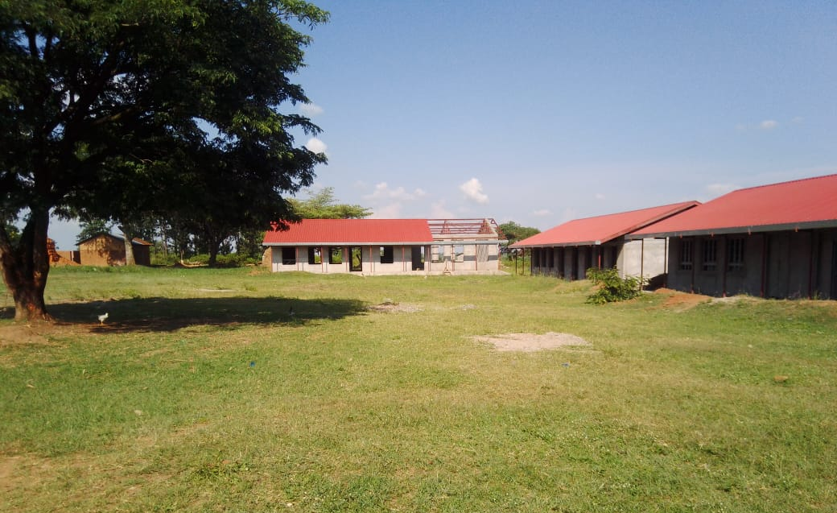

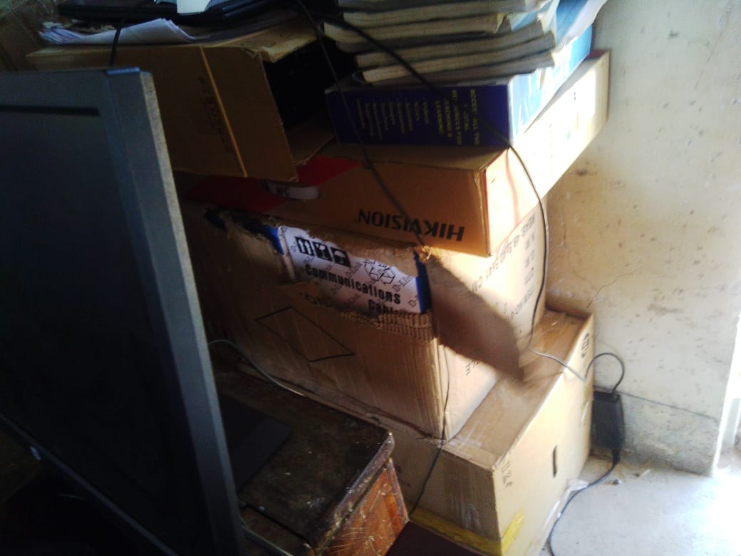

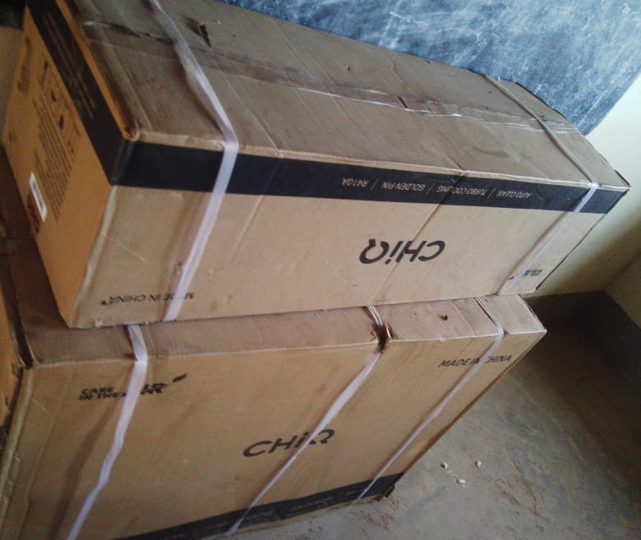
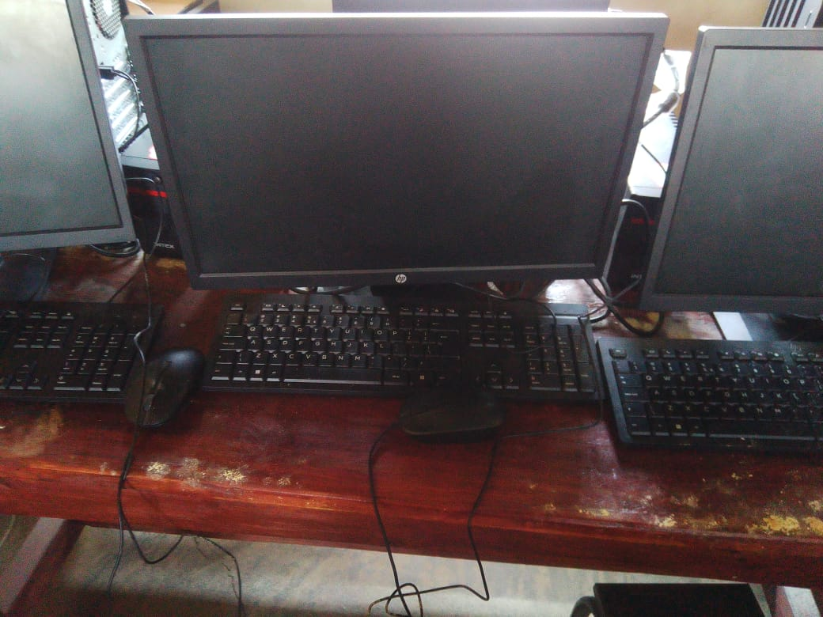

ATEGO SEED SCHOOL, ATEGO SUB-COUNTY IN NEBBI DISTRICT
Information from the focal person in charge of the facility. We were warmly welcomed by the headteacher and given a guided tour around the school premises as we did the asset verification, the school so far benefited from UGIFT Program. A list of delivered ICT assets was shared.
Note: The facility is still under construction and has not been fully commissioned however, they use old structures to store the supplied UGIFT assets specifically ICT assets. These assets are connected and fully functional.
The student turn up has increased and generally parents know the benefits of education based on performance.

FINDINGS
- 3 Blocks each with 2 class rooms
- 1 Science laboratory block with two labs i.e. Biology and Chemistry
- 1 ICT block with two labs i.e. Computer room and Library room
- 6 Staff house units with 6 staff Kitchen units
- 2 Toilets at staff quarters each with 2 stanzas still on pit excavation level
- 1 staff school toilet with 2 stanzas still on slab level no structure
- 2 student toilets for both girls and boys each with 5 stanzas
- Fenced

FURNITURE
- 120 desks
- 10 office chairs
- 290 Laboratory stools
- 10 office tables with drawer lockers
- 278 student chairs
- 7 Shelves cabinets
- 75 tables

ICT DEPARTMENT
- 28 Dell Desktop 19.5 Inch Display Monitor
- 3 CCTV Camera

CHALLENGES
- There is a challenge of power surges. There is need for a stable power supply.

RECOMMENDATIONS
- There is need for a stable power supply to prevent power surges
Field photos
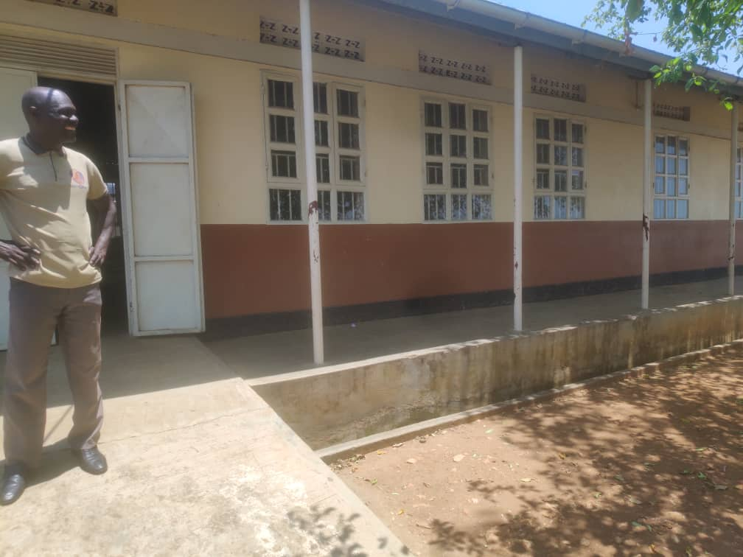
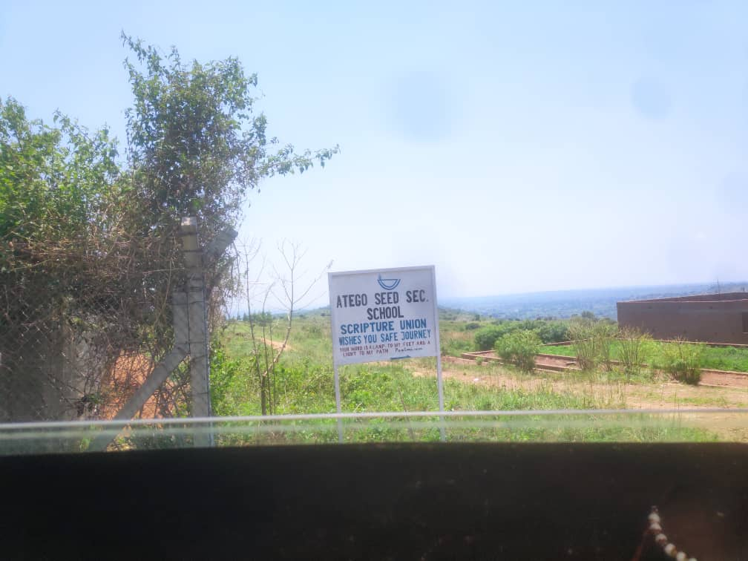

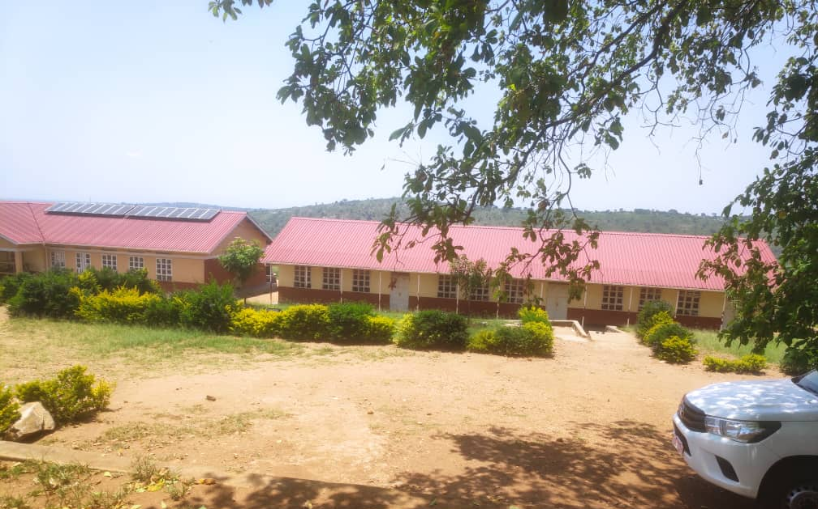
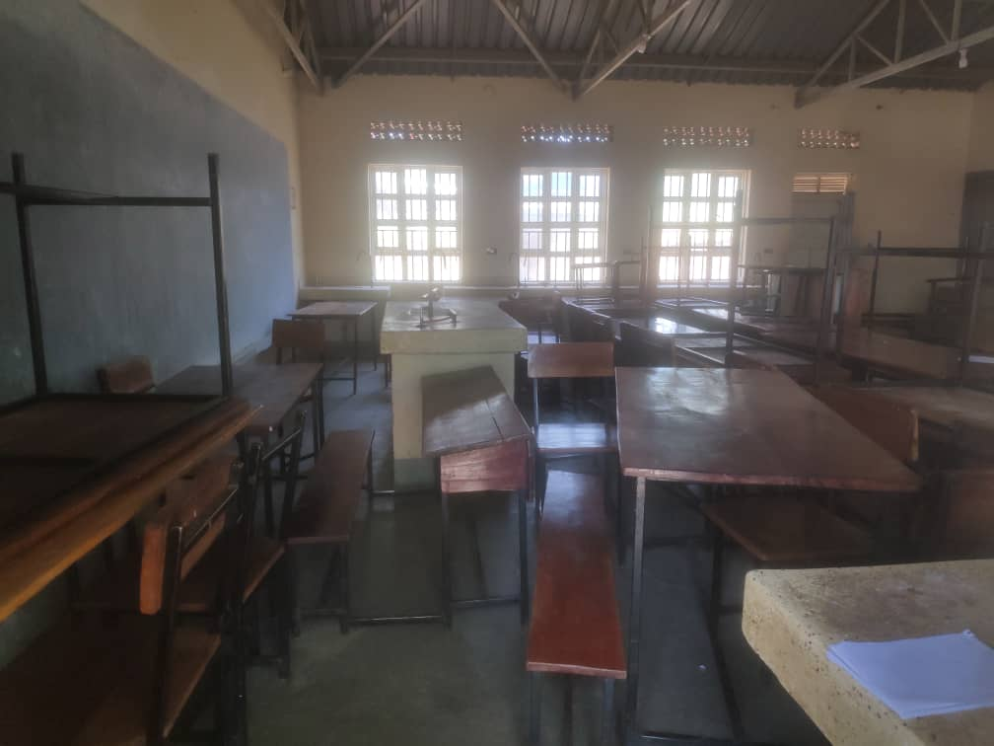

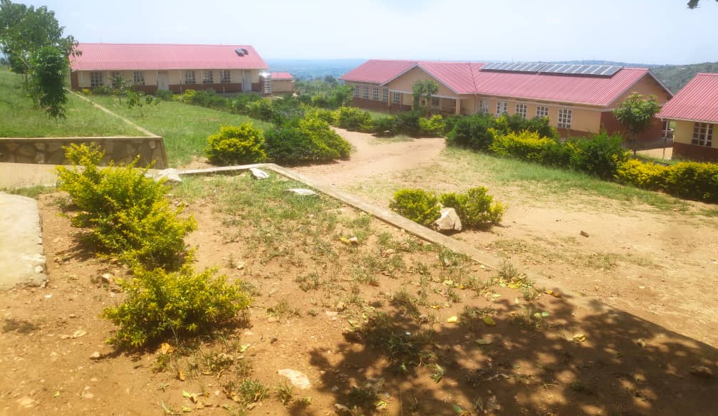
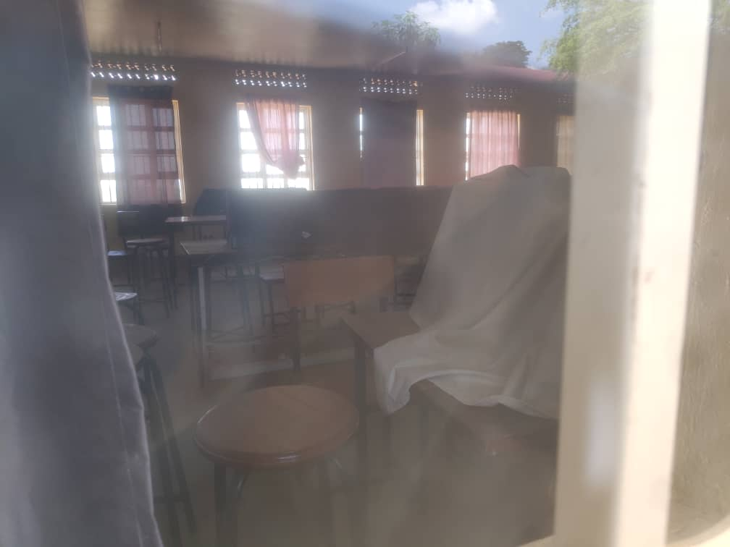

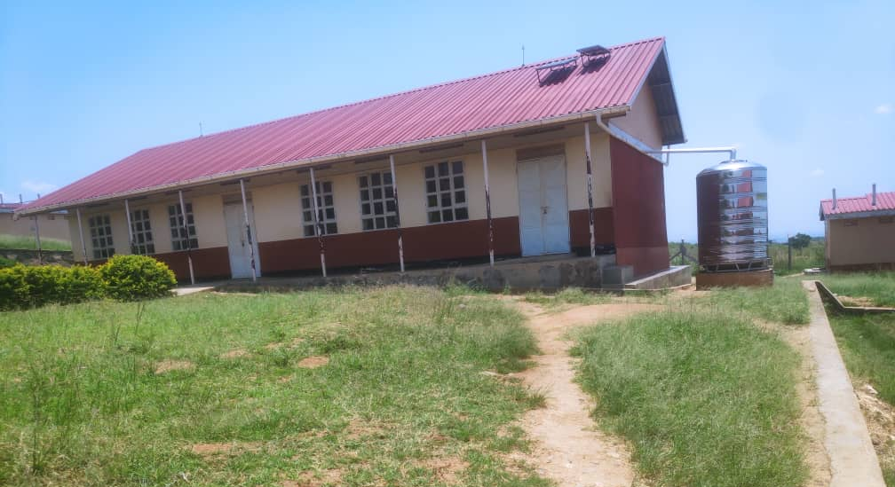
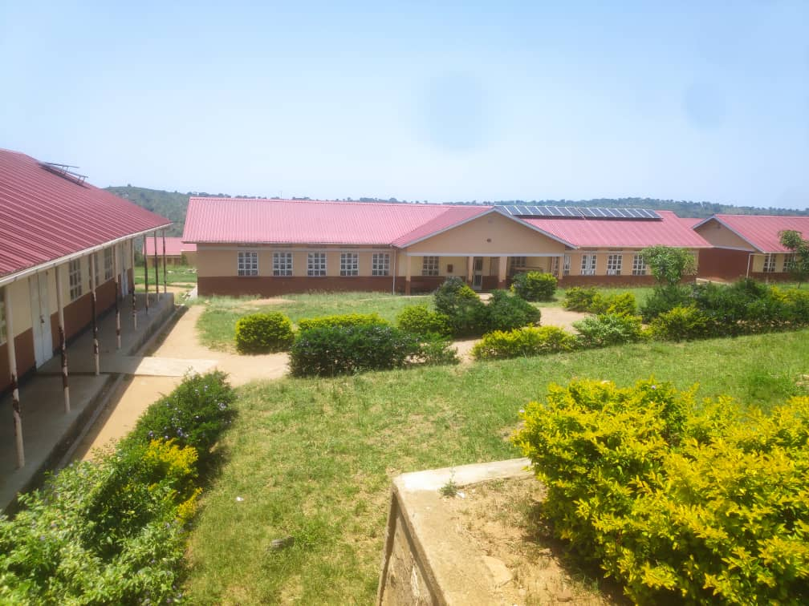

Report compiled by:
Isah Lukwago and Stella Male

